Postman Collections:
a)Installed - DONE
b) Imported collections- DONE
- https://api.groq.com/openai/v1/audio/transcriptions
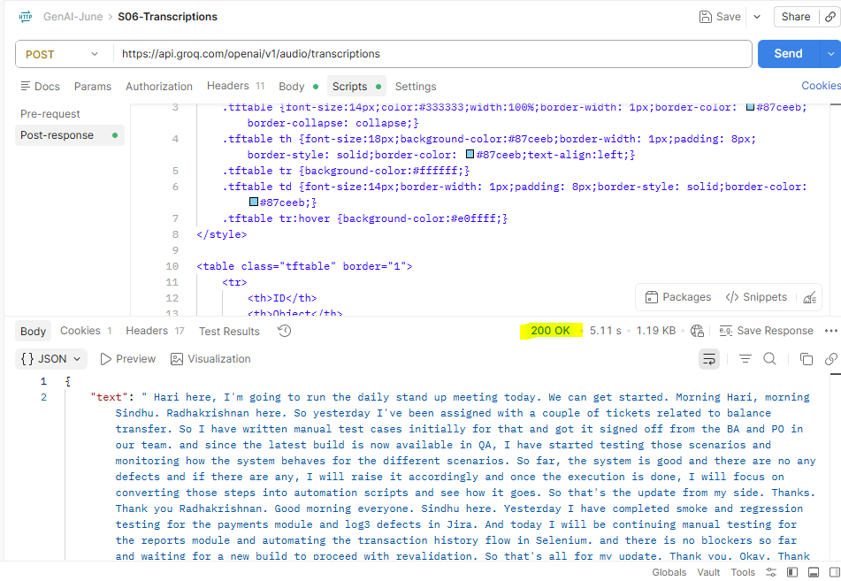
- https://api.groq.com/openai/v1/chat/completions
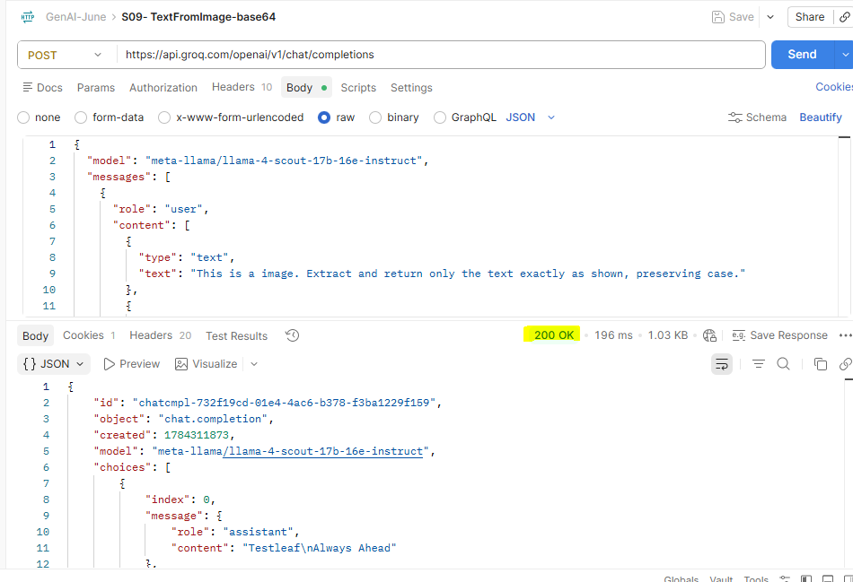
- https://api.groq.com/openai/v1/chat/completions
